**# VISTA3D Build and Service Guide**

**This guide explains how to set up and run the VISTA3D segmentation service from source code.**

**## Quick Setup (Recommended)**

**1. Extract the VISTA3D-Source.zip file to a directory of your choice.**

**2. **Right-click on `build.bat` and select "Run as administrator".\*\***

**3. When prompted, download the model file:**

**- Download from:** [**https://drive.google.com/file/d/1DRYA2-AI-UJ23W1VbjqHsnHENGi0ShUl/view?usp=sharing**](https://drive.google.com/file/d/1DRYA2-AI-UJ23W1VbjqHsnHENGi0ShUl/view?usp=sharing)

**- Save it to the `vista3d/models` directory as `model.pt`**

**4. From the menu, select option 1 to start the VISTA3D service.**

**That's it! The service will monitor the `vista_service/tasks` folder for task files.**

**## Testing the Service**

**To test the service without the Rust application, create a task file in the `vista_service/tasks` directory:**

**### 1. Full Segmentation (Segment Everything)**

**Create a file named `test_full.json` with this content:**

**```json**

**{**

**"task_id": "test_task_full",**

**"type": "full",**

**"input_path": "path/to/ct_scan.nii.gz",**

**"output_path": "path/to/output/directory"**

**}**

**```**

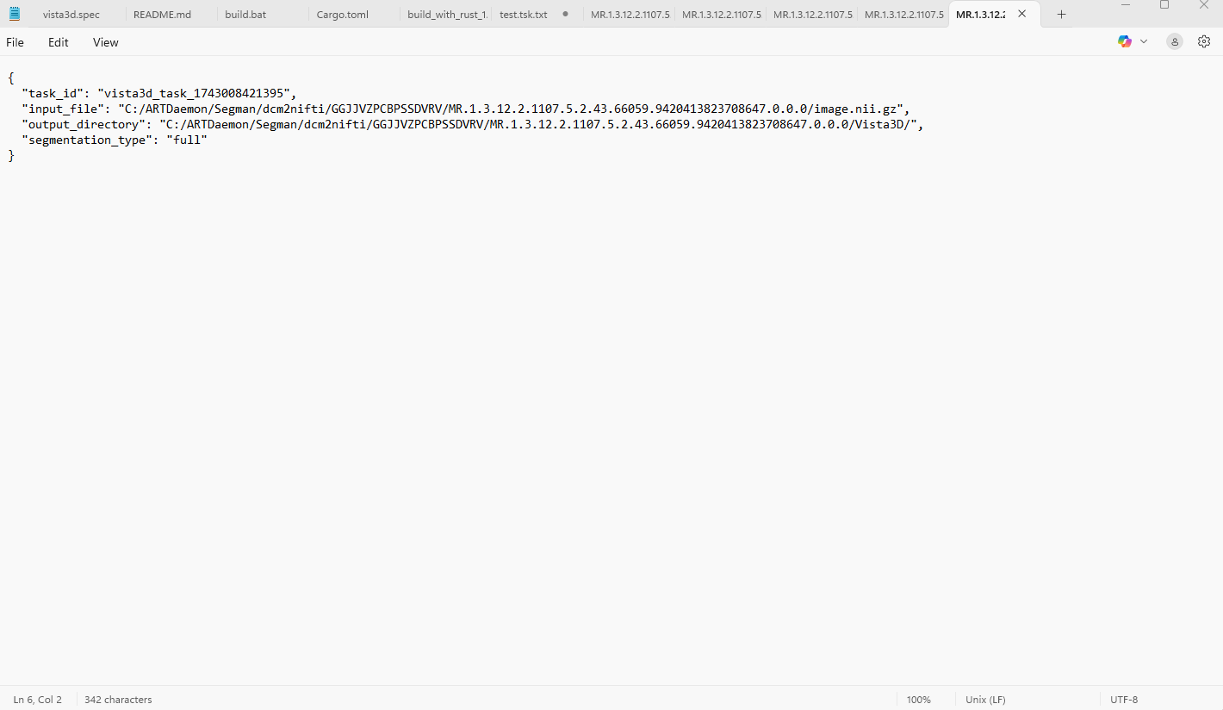

**This will segment all supported organs in the CT scan.**

**### 2. Point-Based Segmentation**

**Create a file named `test_point.json` with this content:**

**```json**

**{**

**"task_id": "test_task_point",**

**"type": "point",**

**"input_path": "path/to/ct_scan.nii.gz",**

**"output_path": "path/to/output/directory",**

**"point_coordinates": [175, 136, 141]**

**}**

**```**

**VISTA3D will automatically segment the structure around the specified point coordinates without requiring a specific organ label.**

**### 3. Organ-Specific Segmentation**

**Create a file named `test_organ.json` with this content:**

**```json**

**{**

**"task_id": "test_task_organ",**

**"type": "organ",**

**"input_path": "path/to/ct_scan.nii.gz",**

**"output_path": "path/to/output/directory",**

**"label": 1**

**}**

**```**

**This will segment only the specified organ (in this example, the liver).**

**### 4. Combined Point and Organ Segmentation**

**Create a file named `test_point_organ.json` with this content:**

**```json**

**{**

**"task_id": "test_task_point_organ",**

**"type": "point",**

**"input_path": "path/to/ct_scan.nii.gz",**

**"output_path": "path/to/output/directory",**

**"point_coordinates": [175, 136, 141],**

**"label": 1**

**}**

**```**

**This combines point-based and organ-specific segmentation, targeting a specific organ (liver) at the given point coordinates.**

**## Common Label IDs**

**If you want to segment specific organs, use these label IDs:**

**- 1: Liver**

**- 2: Spleen**

**- 3: Kidney (left)**

**- 4: Kidney (right)**

**- 7: Pancreas**

**Note: The full list of supported organs can be found in the VISTA GitHub repository's `data/jsons/label_dict.json` file.**

**## Troubleshooting**

**- If you encounter CUDA errors, make sure your NVIDIA drivers are up to date.**

**- Check the log files for errors:**

**- `vista_service.log` - Service log**

**- `vista3d/inference.log` - Inference log**

**## Advanced Setup (Optional)**

**For manual setup or advanced configuration, refer to the [detailed instructions](https://github.com/Project-MONAI/VISTA/blob/main/vista3d/README.md) in the MONAI VISTA repository.**